Club Support Officer Candidate Pack

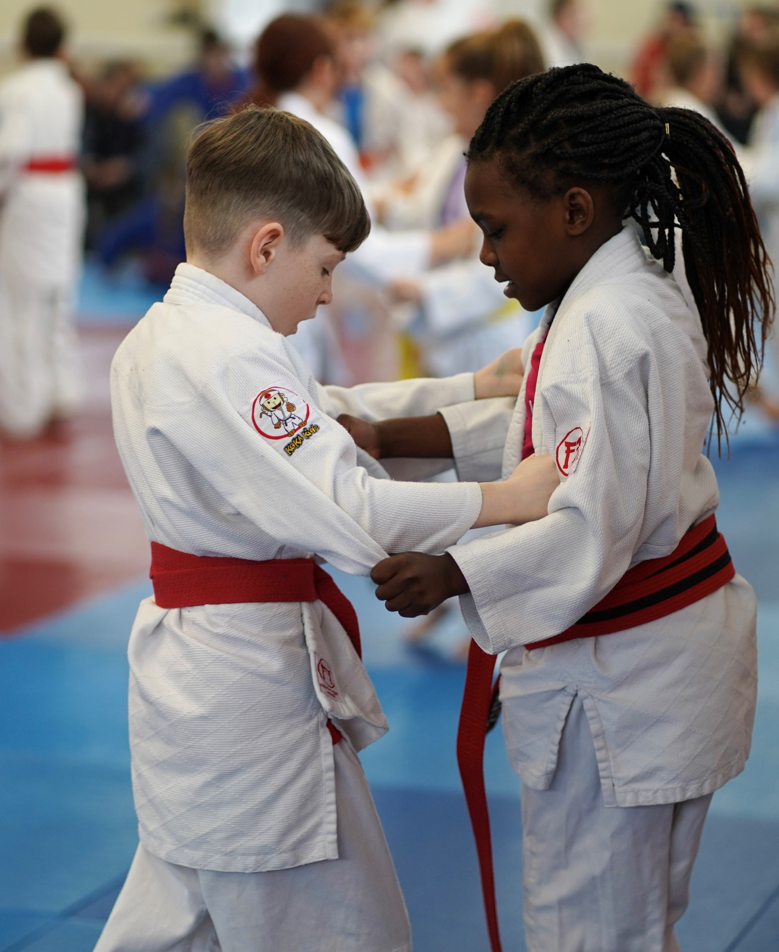

Job Title | Club Support Officer
Place of Work | JudoScotland, Fourth Floor, EICA Ratho, South Platt Hill, Newbridge, EH28 8AA
Business Area | Business Delivery Team
Responsible To | Head of Business Delivery
Hours | 37.5 hours – part time/full time/job share options available
Salary | Level 1: £21,255 to £30,000
Annual Leave | 36.5 days per year inclusive of 6.5 days public holiday/Christmas shutdown

Overview
JudoScotland is the sportscotland recognised Governing Body for the sport of judo within Scotland. It currently has a growing membership of over 8,000 individuals and supports more than 190 clubs. JudoScotland is committed to growing a more engaged, diverse membership and providing progressive, inclusive opportunities across all levels through the delivery of its new strategy ‘Judo For All' (2023 – 2027).
Background
The role of Club Support Officer sits within the Business Delivery Team, which is responsible for the operational delivery related to club & member development, coaching & workforce, safeguarding & events.
Primary Job Purpose
Working through the Head of the Business Delivery Team, you will assist the organisation to achieve its mission to “Maximise the contribution of judo to Scotland’s communities through the provision of safe, inclusive and inspiring clubs based on judo’s values.” You will be responsible for empowering and enabling clubs to make a positive contribution to Scottish society and to grow an engaged, diverse membership. In partnership with key stakeholders and colleagues you will assist in the provision of progressive, inclusive opportunities for clubs and members.
Responsibilities and Duties
- To provide support in the development of targeted and inspiring initiatives and opportunities to attract and retain members. This includes working with external partners to tackle inequalities within judo in Scotland.
- To provide bespoke club support to empower existing and new clubs to thrive in communities throughout Scotland.
- To promote and support clubs through the Club Development Framework while sharing all relevant updates and guidance and to provide training where necessary using a variety of platforms.
- To support the People Development Executive by sharing and promoting workforce training opportunities to help build targeted opportunities to attract, develop and retain a more diverse workforce of coaches, technical officials, referees and volunteers.
- To actively encourage clubs to participate in JS Grading Scheme which can be a useful retention tool as well as a development opportunity for the member.
- To work closely with the National Talent Development Coach to support clubs and coaches to deliver training to relevant judoka that supports performance pathway development and to promote the use of the Player Development Framework within clubs to support player development.
- To be responsible for creating partnership links and developing existing links where there are common goals and shared ambitions.
- To support the Events Executive by promoting and encouraging clubs to access relevant events and competitions and where required, to support the delivery of those events.
- To work alongside the Communications & Marketing team to improve the profile of judo in Scotland by sharing case studies and stories from clubs and members. To identify marketing tools that would benefit club growth and member retention.
- To work closely with Business Delivery colleagues to create awareness of, and to deliver a Young Leaders Programme.
- To support clubs in ensuring that wellbeing and protection considerations are embedded across all areas of their work
- Create/support legacy planning from major events as well as uniting the Judo community through a supporter’s network.
- To regularly undertake data monitoring of clubs and members, utilising the data to inform initiatives to meet JudoScotland strategic ambitions.
- To create and develop reports on a regular basis for the Senior Leadership Team, Board of Directors and any relevant key partners.
- To undertake other activity as directed by your Line Manager or Chief Executive Officer.
Knowledge, Skills and Experience Required
- Knowledge and experience of sports development.
- Experience of working with multiple stakeholders.
- Experience of working with volunteers.
- Strong interpersonal and communication skills.
- The ability to work both as part of a team and individually, with demonstrable experience of motivating, leading and enthusing others.
- Willingness to work evenings/weekends when required.
- A comprehensive, demonstrable understanding of Microsoft Office and other software packages.
Application Process
- For an informal conversation about this role please call:
- Tony Penfold (Head of Business Delivery, JudoScotland) on 07949 888074, or
- Samuel Ingram (Club Support Officer, JudoScotland) on 07738 846529
- Please complete the below application form and Equal Opportunities Monitoring Form (this will not be seen by the panel which shortlists or interviews) to hr@judoscotland.com, with the email subject: “Club Support Officer Recruitment”.
- Closing date for applications will be 9am on Monday 2nd October 2023, with the interviews to be held week commencing 16th October 2023.

Name of Position Applied For
Club Support Officer

Personal Details
Surname:
First Name(s):
Address:
Contact Number:
Email Address:

Education (Secondary, Further and/or Higher)
Dates From & To:
Qualification Awarded:
Name of Establishment:
Subjects Studied:
Dates From & To:
Qualification Awarded:
Name of Establishment:
Subjects Studied:
Dates From & To:
Qualification Awarded:
Name of Establishment:
Subjects Studied:

*Employment History (most recent first)
Dates From & To:
Name of Employer
Job Title
Primary Duties
Reason for Leaving
Dates From & To:
Name of Employer
Job Title
Primary Duties
Reason for Leaving
Dates From & To:
Name of Employer
Job Title
Primary Duties
Reason for Leaving
Dates From & To:
Name of Employer
Job Title
Primary Duties
Reason for Leaving
Dates From & To:
Name of Employer
Job Title
Primary Duties
Reason for Leaving
*Please complete on a separate sheet if necessary
Knowledge, Skills and Experience
Please provide details of your experience of sports development strategies:
Please provide details of your experience of working with multiple stakeholders and volunteers:
Please detail below your experience of interpersonal and communication skills:
Please detail any further information you feel is relevant to the role:

Reference Request
 | Reference 1 | Reference 2
Name:
Address:
Contact Number:
Email Address:

Application Details
Closing Date: | 9am on Monday 2nd October 2023
*Interview Date: | Week commencing 16th October 2023
Special Requirements: | Do you require any special arrangements for interview:-
Notice Period Required:
Driving Licence: | Yes/No

Declaration
I understand that the information I have provided is accurate and I have completed and submitted the Equality Monitoring Form under separate cover.
Signature:
Date:

* Please note that applicants being short-listed for interview will be contacted by Monday 9th October 2023. If we have not contacted you by this date, regrettably you have not been short-listed on this occasion and JudoScotland would like to thank you for your time and interest in the advertised position.

